www.treecityquilt.com March 2020
Next Meeting – March 9, 2020 - 7:00 PM
General Meeting
Monday
March 9, 2020
7:00 PM
Doors open
at 6:30
Oak Hammock
2nd Floor
Oak Room
5100 SW 25th PL
Gainesville, FL

Scrap Management – Is it possible?

Do you collect scraps until family members want to stage an intervention?
We will give you some ideas on how to enjoy quilting to its fullest while avoiding avalanches of untended scraps.
We will show you how to cut those odd pieces of fabric into something manageable and how to incorporate them into a “true scrappy” quilt. Members will share some of their own quilts which were made from their scrap collection.
We would love to see what you have done with your scraps. It doesn’t have to be a quilt. Pillows, postcards, pincushions…..
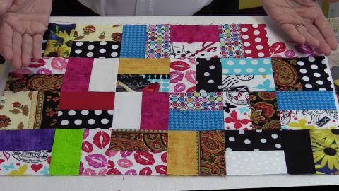
We will have a scrap bundle exchange. A “True Scrappy Quilt” pattern will be available. It calls for many 2 inch by 3 ½ inch strips cut from fabric of any color or pattern. If you’d like to participate, bring your bundles of 10 strips - cut to this correct measurement. For each bundle of ten you bring, you will take a bundle of ten.
Please use a safety pin to hold the ten strips together.

Tree City Quilters Guild Mission Statement
The purpose shall be to preserve the heritage of quilting by being a source of information, education, and inspiration, by perpetuating a high quality of excellence in quilting and
related arts, and providing a gathering of people with this common interest.

Tree City Quilters Spring Retreat
Retreats
Jean Genton
Friday and Saturday – April 3rd and 4th
Grace Baptist Church 7100 NW 34th
1Day - $25.00 2 Days - $45.00
- Includes 2 meals per day
Registration & fees due by March 20th.
*Registration form in newsletter

* There will be a fundraising fabric sale at the retreat. Proceed to benefit charity and programs.

President’s Message
For a 27-year period of my life, my address changed every three years. No, I was not a fugitive from the law. I was a military wife.

President:
Linda McSwain
Vice President:
Charlene
Stroehlen
Treasurer:
Peggy Bessinger
Secretary:
Cathy Silloway

Newsletter:
Linda McSwain,
Editor

I was overjoyed when we made the final decision to plant ourselves in Gainesville which happened to be close to our kids and grandkids. I enjoyed spending every possible moment with my grandbabies, but I needed a hobby. I had always had a strong interest in quilting. One evening fourteen years ago, I went to my first TCQG meeting and ….the rest is history.
What have I gained or accomplished in all those years as a member?
First and foremost, I have made some amazing friends.
Second, I’d like to think I am a better quilter. This is due to the workshops, programs, retreats, and all those members who are always willing to share tips and techniques.
I have made quilts for those in need and seen the expression of gratitude on their faces when they are delivered.
I have co-chaired a quilt show which was one of the biggest projects I have ever taken on, but also the most rewarding.
Also, thanks to all of you, I have almost conquered my fear of speaking in front of groups. This was a hard one for me. And… between you and me, I DID picture all of you in your underwear.
These are just some of my accomplishments. I hope you, too, have benefitted from being a part of the guild and all it has to offer. I can’t wait for all the friendships and adventures in the years ahead.
Linda

Come be a part of our TCQ Charity Sewing Group
Monday, March 16, 2020 From 10 AM to 2 PM
Charity
Gwen Lombard

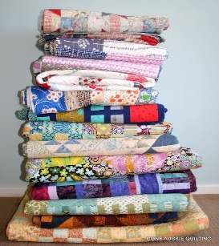
We will be meeting at the Senior Recreational Center, 5701 NW 34th Blvd (across the street from Walmart). Our meeting space at the SRC is the Shand’s Room. Bring your sewing machine and lunch. Or, if you want to order your lun ch and have it delivered by Subway, stop at the front desk upon your arrival and place your order with the receptionist.
Please remember to scan your Elder Care card either when you arrive or before you leave the center. This is how the center keeps track of how well we are using their space. Hope to see you there.

Spring Food Bank Drive
We will do our spring food bank drive at our meeting in March. If you wish, bring non-perishable food, cash, or check made out the to Bread of the Mighty Food Bank. Thank you. Vicky Bergath

Rhonda Sailors Sallie Glaze
Theresa Morales
Marie Addison
Tammy Clark

Now Open: Julie’s Pins and Needles
18646 Main St. Suite 10 High Springs

Iron Caddy Tote Workshop
Saturday, March 14, 2020
10:00 am – 2:00 pm
Grace Baptist Church
7100 NW 39th Ave, Gainesville, FL 32606

Workshop Time!
Register Soon!
Instructor: Tammy Clark
This is a tote you carry your iron
In and once open, it is also your
Ironing surface.

Cost $15 for members
$18 for non-members

There must be a minimum of 7
Prepaid attendees 7 days in
Advance or the class will be
Cancelled. Cost must be paid directly to workshop chairperson. Checks payable
To TCQG.

Chairperson: Trish Everitt
5405 SW 78th Terrace
Gainesville, FL 32608

trishsmecca@yahoo.com
for questions or if you plan
to attend.

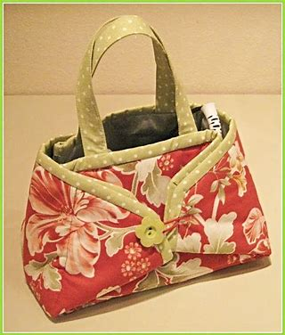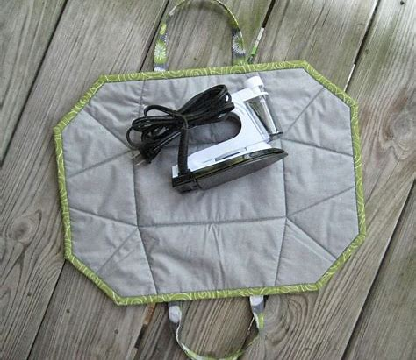

Supplies:

Fabric
Contrast fabric for binding & straps
Insulbrite
Silver ironing board fabric
Batting
¼“wide elastic
Freezer paper
2 Buttons
Pencil
Ruler that’s at least 26” long
Rotary cutter
Cutting mat
Sewing machine
Sewing supplies
Pins or clips to hold fabric together
Walking foot (you will be sewing through 5 layers of material)

Please cut each of the following items to 19 ½ x 25 ½ before class:

- Focus fabric
- Insulbrite
- Silver ironing board fabric
- 2 pieces of batting
- Freezer paper

Cut two pieces of elastic to 4” long.
Cut two pieces of contrast fabric to 4” x 21”.
Cut two pieces of batting to 1” x 21”.

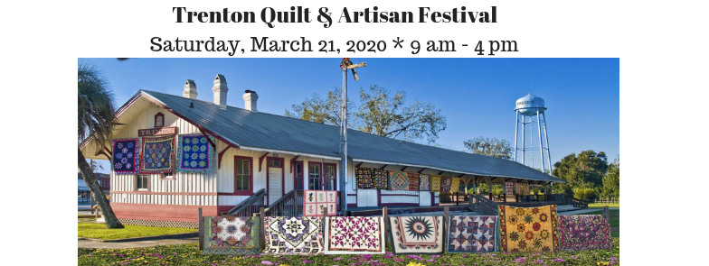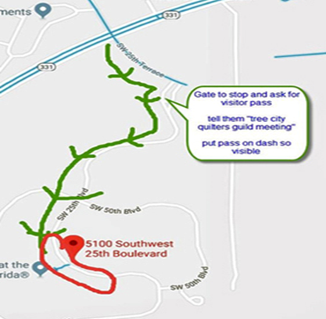
Directions to Oak Hammock

The turn off for Oak Hammock is at SW Williston Road (331) and SW 25th Terrace,
You will see the “Oak Hammock” sign at the
Corner.
Follow the road to the Gate House and ask for
a pass. Tell them you are with Tree City
Quilters Guild.
Place pass on dash where it is visible.
Follow road until you see the building with the
Large flag pole.
Meeting is on the 2nd floor of this building in
The Oak Room.
Bring to Meeting:
- Nametag
- Show and Tell
- Charity Quilts
- Snacks – March birthdays
- Lotto Block
- 2 inches by 3 ½ fabric strips (in sets of ten)
- Retreat form and fees
- Workshop form and fees
- The item or quilt made from your fabric scraps that you’d like to share
- Cash, Check, or Food for the Food
Bank Drive

Announcements:

Please welcome TCQ New Member, VANDA O’NEILL, who joined the guild in February, 2020.

Ken Crenshaw, Ft. White Community Thrift Store will pick up large items or donations in Gainesville. He works full time in the Gainesville area. He is a volunteer for the Thrift shop. His cell is 352-317-7839. Call if you have a donation that you would like picked up.

If you would like to donate an item (s) for our monthly door prize drawings, please contact Jackie Reichardt – jackiesewbad@aol.com.

Please – No snacks, deserts, or fruit trays with oranges at the monthly meetings. One of our members has a severe allergy.

Want to add something to the newsletter or agenda? Contact Linda McSwain.

Does anyone know where we can find the Guild’s silverware? Please contactLinda McSwain or Marsha Tucker if you know where it’s hiding.
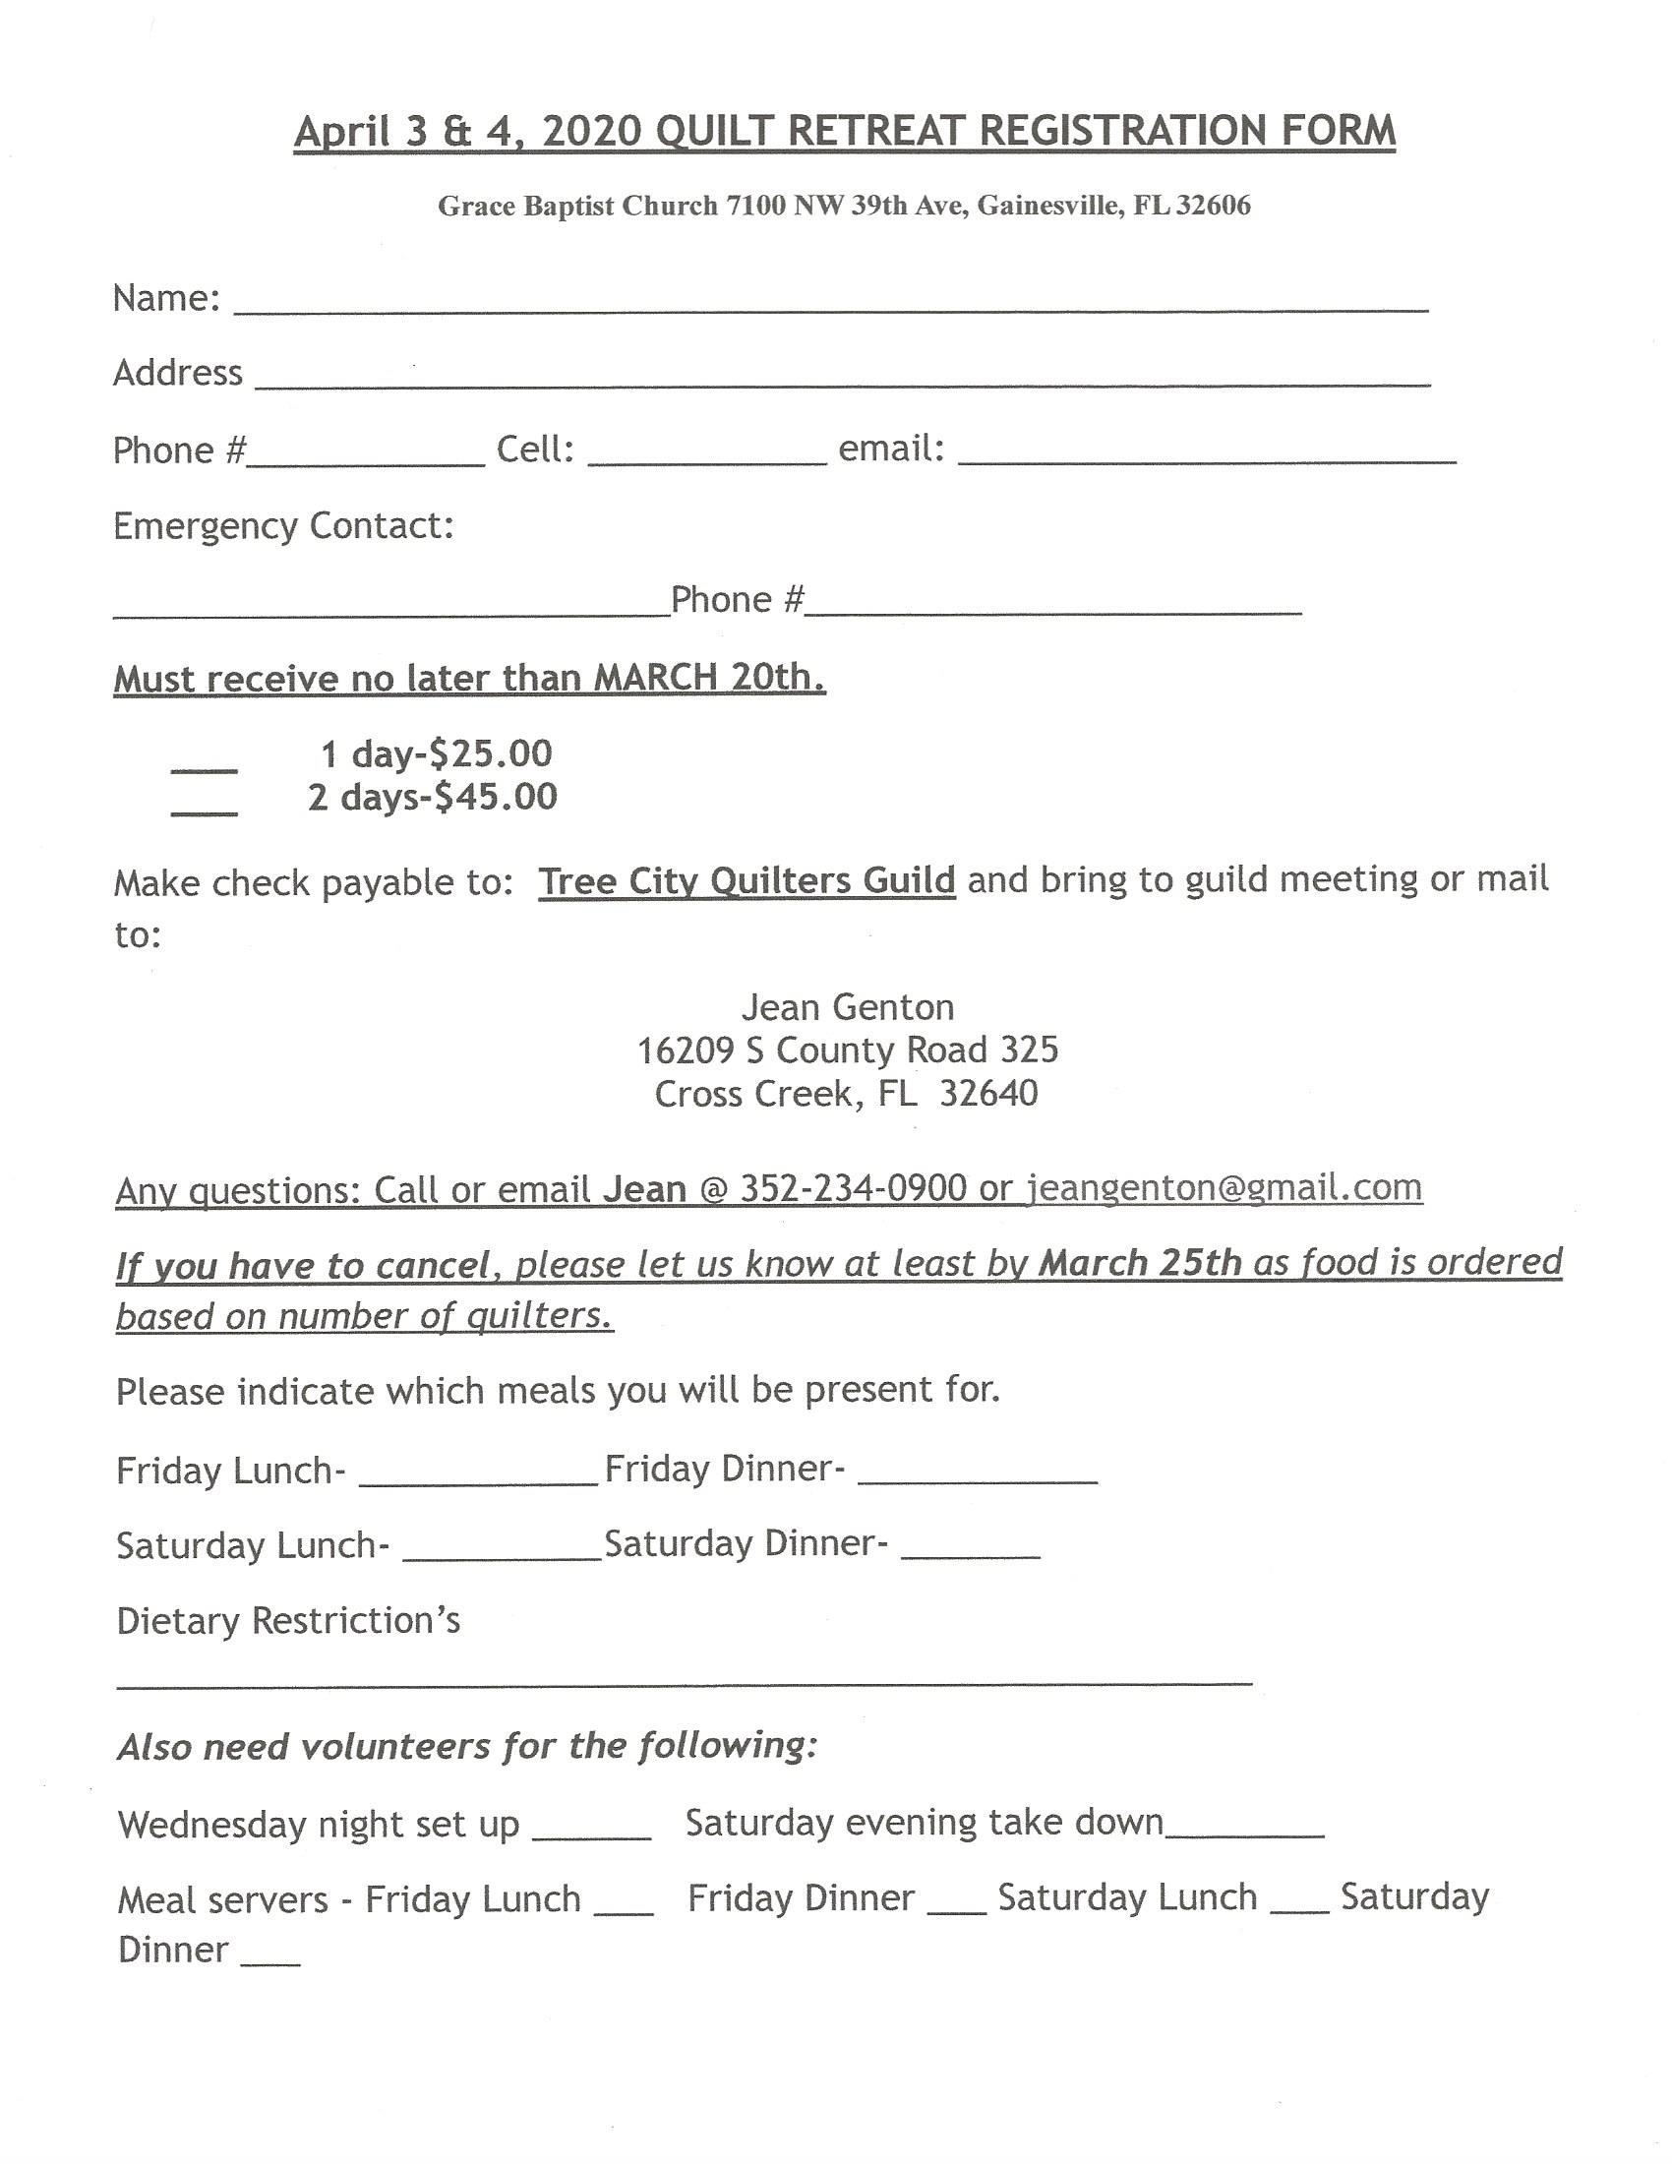
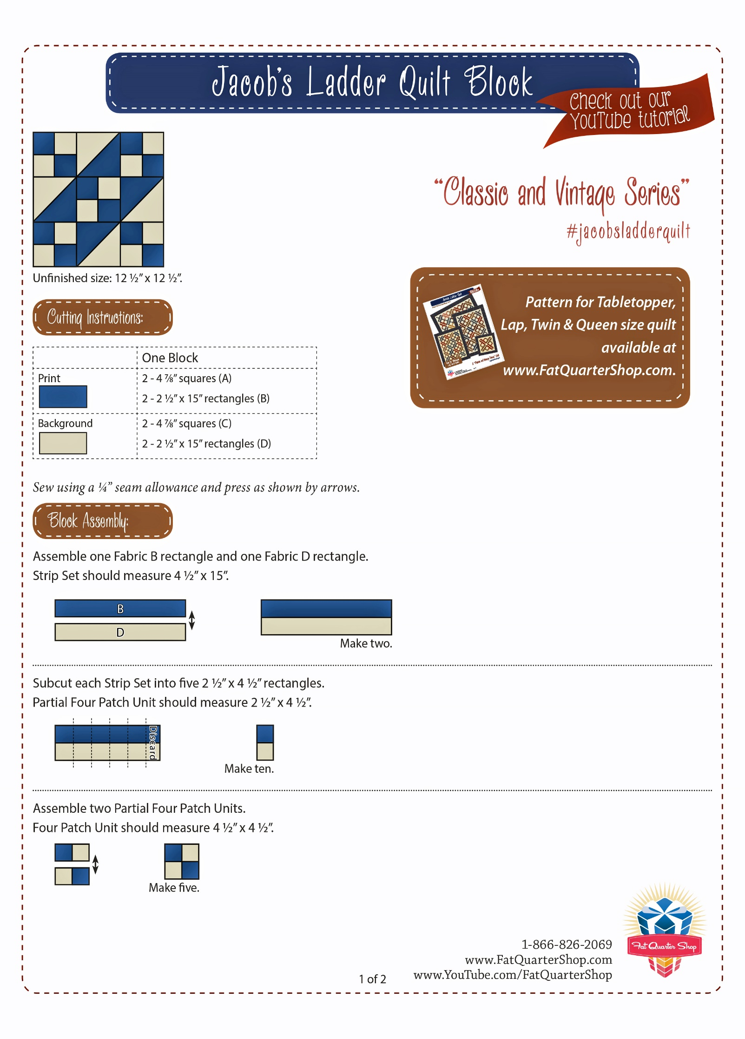
Page 2 of Jacob’s Ladder Pattern
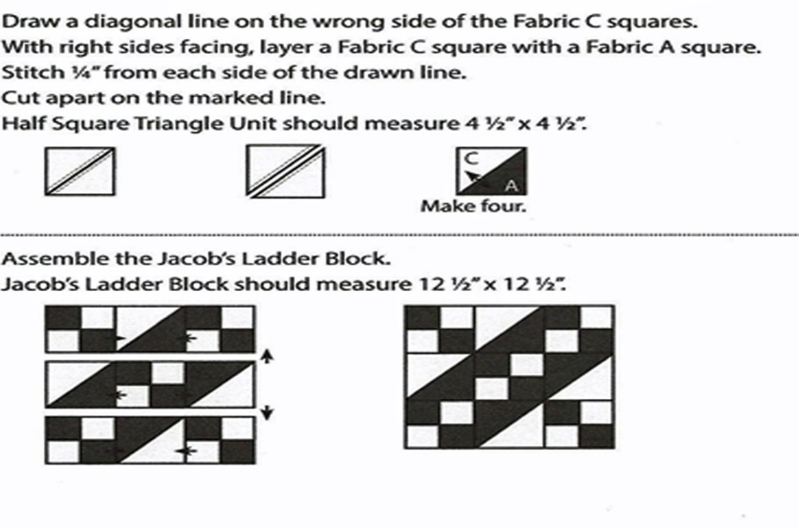
TCQG Monthly Meeting Minutes Feb. 10, 2020

Attendance: 44. Three new members and one guest.

Program Speaker: Aggie Czarnezki from the Fabric Art Shop in Lake CIty

Treasury's Report: Peggy and Linda reported on the status of the current budget.
Bank Balances on Jan 27, 2020=
$2988.92 - Checking
$3943.71 - Savings
$8595.63 = Total

Board Meeting Report - Meeting took place in January and found we have increased our overall budget since May of 2019 by $1713. Various fundraising efforts within the guild have made this happen!

Charity Committee - Linda reported there will be a need for a new member to head a Charity Committee in the months ahead. Anyone interested can speak to Gwen or Linda.

Charity- Gwen reported she will be stepping down from Charity Chair. She reported kids’ quilts will be made at the next charity sewing day. They meet the third Monday of each month at the Senior Center.
Vicky reported on the food bank: members can bring canned food items, check or cash, to next month’s meeting. All will go to the Bread of the Mighty Food Bank.

Workshops - Iron Caddy Tote Class - Cost: $15 - member / $18 - non-member
Saturday March 14th 10am - 2pm at Grace Baptist Church

Retreat - Our next TCQG Retreat will take place on April 3rd and 4th. The cost is $25 for one day and $45 for two days.

Tip of the Month - Sandy spoke about why sewing machine maintenance and cleaning should be a priority.

Block Lotto - Instructions for the next block will be available on the monthly newsletter and Facebook.
Meeting Adjourned Submitted by Cathy Silloway

